Chapter 12, Solution 76.

If both appliances have the same power rating, P,
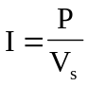

For the 120-V appliance, 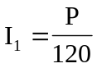.
For the 240-V appliance, 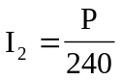.

Power loss =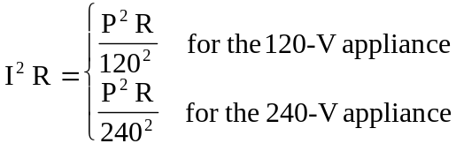

Since 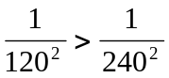, the losses in the 120-V appliance are higher.

